

A Report On
Special Project-1
Submitted by
Tarun Ajendla and J. Pawan Kalyan
20STUCHH010130,20STUCHH010020



FACULTY OF SCIENCE AND TECHNOLOGY
The ICFAI Foundation for Higher Education,
Hyderabad

October 2022

ABSTRACT: -

Software agents known as voice assistants can understand spoken language and respond with synthetic voices. The most well-known voice assistants are Google Assistant, Apple's Siri, Amazon's Alexa, Microsoft's Cortana, and Apple's Siri, and they are all built into smartphones or specific home speakers. Users can use voice commands to manage other common chores like email, to-do lists, and calendars in addition to asking their assistants questions, controlling home automation devices, and controlling media playback. This article will examine the fundamental principles and typical features of today's voice assistants.

Python is a good language for developers and scriptwriters, as we all know. We made the decision to use Python to create a Voice Assistant script. The user can change the assistant's question

TABLE OF CONTENTS
Chapter |  | Name | Page No.
01 |  | INTRODUCTION | 3
 | 1.1 | Advantages | 5
 | 1.2 | Disadvantages | 7
02 |  | Plan of work | 8
 | 2.1 | Modules needed | 9
 | 03 | Coclusion | 11
 | 04 | References | 11

INTRODUCTION
Modern society has made daily living smarter and more technologically connected. We are already familiar with voice assistants like Siri, Google, etc. It may now serve as a rudimentary medical prescriber, daily calendar reminder, note writer, calculator, and search tool using our voice help system. This project uses voice input, produces speech output, and displays text on the screen. Our voice assistant's primary goal is to educate individuals and provide quick, calculated results. The voice help receives voice input from our microphones (wired and Bluetooth) and turns it into computer-understandable English before providing the user with the necessary solutions and replies. This support makes a connection to the Internet to give users with results they have questioned. A natural language processing algorithm enables computer systems to communicate using many forms of natural human language.
This system is made to work effectively on desktop computers. The management of repetitive chores by the user and the provision of information from an internet source are two ways that personal assistant software increases user productivity.

The foundation of this project is the idea that there is enough freely accessible data and information online that may be used to create a virtual assistant with the ability to make wise decisions on common user tasks.

Advantages

- Users can speak on the phone using the voice user interface without needing to hold it close to their ears. You only need to push a button to answer the call if it rings when you are in an uncomfortable situation, such as bathing or driving, and then you can talk to the caller hands-free.
- If you are familiar with how VUI devices operate, you can use one as an extra hand and time saver. You can ask Google Maps for directions while driving by speaking to it and letting it know where you want to go. You'll have a lower likelihood of getting lost as a result. It saves you from having to get out your phone and look up the route on the map.
- So that your personnel can be placed in better positions, it can take over a lot of the boring tasks associated with phone operation. Both incoming calls and SMS text messages can be handled by it. Additionally, it has the ability to forward your calls to another number. It can convert your spoken words into text that is typed in the page, so you can tell it to take down notes. It is the ideal solution for administrators who prefer to work primarily in front of computers rather than surrounded by notes on their desks.
- It can be a very useful tool for those who have disabilities. The VUI gadget can read emails, articles on websites, and documents aloud to people who are blind or visually challenged. It can turn audiobooks and communications into text so that persons with hearing impairments can read them on a computer screen. Using their hands to interact with the products is challenging for people with disabilities. By incorporating technology into your product, you will be able to outsell rivals that produce less usable goods.
- Using a voice recognition technology can make it easier for persons who speak different languages to communicate. This is so that you can comprehend what is being said while it is being spoken in a foreign language because it has an integrated translation function. It can assist tourists in getting past a language barrier so they can

Disadvantages
- Virtual assistants can handle smart home appliances, but they are pricey and not everyone can afford them. They use a lot of electricity as well. Therefore, you should anticipate paying a larger electricity cost if your home has a lot of smart home gadgets. You can't use them while the electricity is out.
- You risk becoming disengaged from the work at hand if you utilise a voice-activated virtual assistant. While giving instructions to the virtual assistant, you are simultaneously attempting to complete the task at hand and paying attention to the virtual assistant. When your focus is split, mistakes are more likely to occur. So be cautious to pause what you're doing before giving a virtual assistant directions.
- Your data may be recorded by the manufacturer if you use a VUI device. The Cambridge Analytica incident, for instance, raised concerns that Google Home and Amazon Alexa were listening in on people's private chats. People start to worry about how these firms will exploit their personal information as a result. Manufacturers are now attempting to provide consumers with improved privacy options so they may use the device in peace after becoming aware of the problem.

Plan of work

We use Visual Studio Code.


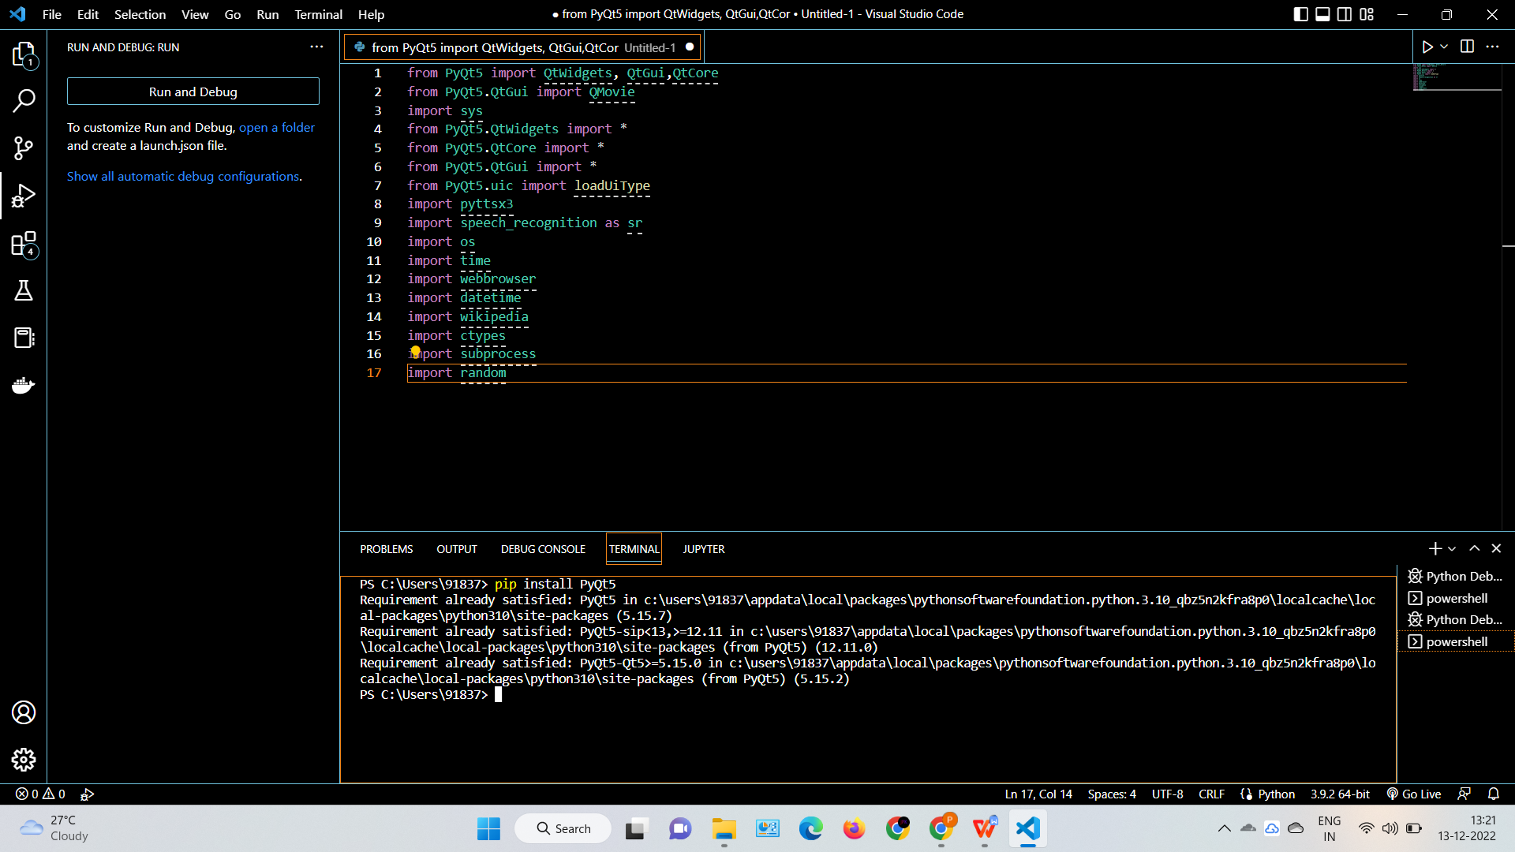

Analyzing the audio commands issued by the user through the microphone was the first step in the process. This could involve anything, such as obtaining information or managing computer files, etc. This study is based on reading the aforementioned material and putting its examples to the test. With the express purpose of discovering best practises and a deeper understanding of voice assistant, tests are made by programming in accordance with books and internet resources.

The difficulties don't end there, though. The software may not be able to understand you even after hundreds of hours of input because of other reasons. A speech recognition system might easily become confused by background noise. This is because it lacks the ability to tell the difference between your voice and the background noises it "hears," such as a dog barking or a helicopter buzzing overhead. Engineers must programme such capability into the apparatus; they gather data on these background noises and "teach" the apparatus to filter them out. Speech recognition algorithms may be sensitive to the way people instinctively adjust their voice pitch to compensate for noisy situations, which is another factor.

In speech recognition, audio is transformed into text. This is frequently employed by voice assistants like Siri, Alexa, and others. Python offers an API called SpeechRecognition that enables audio to text conversion for further processing. In this post, we'll examine how to use Python's SpeechRecognition API to transform lengthy or big audio recordings into text.

Modules Needed

- Subprocess: This module is used to retrieve information on system subprocesses that are utilised in a variety of commands, such as shutdown and sleep. Python already includes this module.
- Pyttsx3:- This module converts text to speech in a programme and operates in the background. Type the following command in the terminal to install this module.install pyttsx3 with pip

- Wikipedia:- We have utilised the Wikipedia module on GeeksforGeeks to retrieve information from Wikipedia or to do a Wikipedia search since, as we all know, Wikipedia is a fantastic repository of knowledge. Type the following command in the terminal to install this module.pip install wikipedia
- Speech Recognition: Since we are developing a voice assistant application, one of the most crucial components of this is that your assistant understands what you are trying to say or ask. Type the following command in the terminal to install this module. Pip install SpeechRecognition
- Web browser:Use a web browser to conduct a web search. Python already includes this module.
- Datetime:- Date and Time are used to showing Date and Time. This module comes built-in with Python.
- The most recent version of Riverbank Computing's GUI widget toolkit is PyQt5. Qt, one of the most effective and well-liked cross-platform GUI libraries, has a Python interface. The Python programming language and the Qt library are combined in PyQt5. You may use PyQt to build graphical applications with the help of this basic tutorial.

- These are required modules for building an voice assistance
from PyQt5 import QtWidgets, QtGui,QtCore
from PyQt5.QtGui import QMovie
import sys
from PyQt5.QtWidgets import *
from PyQt5.QtCore import *
from PyQt5.QtGui import *
from PyQt5.uic import loadUiType
import pyttsx3
import speech_recognition as sr
import os
import time
import webbrowser
import datetime
import ctypes
import wikipedia
import subprocess

Conclusion

The Visual studio community has supported the project's use of open source software components, which can quickly accommodate any modifications. This project's modular design gives it greater flexibility and makes it simple to add new features without impairing existing system functionality.
It not only responds to human orders but also to questions posed by the user or words said by the user, such as opening operations and tasks. The voice assistant is introducing itself to the user in a way that makes them feel more at ease and allows them to engage with it freely. The programme should also get rid of any extra manual labour that is required for users to complete each job. The entire system relies on verbal input rather than visual data, and

References
https://www.geeksforgeeks.org

